Cash for Clunkers

A report on the statistics and merits of this system. Project report for course SYS 660 – Decision Making via Risk Analysis.

Rushabh Barbhaya

Stevens Institute of Technology  Hoboken, NJ

Contents

Summary 2

I. Fuel Savings 3

A. Fuel savings in Cash for clunkers program 3

B. Fuel savings without Cash for clunkers program 3

C. Theoretical savings 4

II. Cost Savings 4

A. Individual Savings 4

B. Corporate Savings 5

III. Societal Benefits 6

IV. Conclusion and Recommendations 6

V. Assumptions and Model Boundaries 6

VI. References 7

# Summary

July of 2009 was when the Car Allowance Rebate System (“Cash for Clunkers”) was introduced with an initial budget of $1 billion, later increased to a total of $3 billion and was ended early, as soon as August 2009 [1]. About 690,114 cars having low fuel economy were traded for high fuel-efficient cars.

Net fuel savings are expected to be 35 million gallons of fuel for the first year. And about 490 million gallons of fuel over 12 years. Which is nearly double to what would have been saved in normal conditions.

An overall reduction of 0.05% was observed for just passenger cars in the United States of America. If 10%-50% savings were the desired values about 60 million vehicles would have to be included in the scope of the entire project which would require $100+ billion investment which puts a huge strain on tax payer’s money.

In the observed scenario, the program saved $125 per car or $0.5 per gallon of fuel. This project didn’t serve its desired results and cost billions of dollars of tax payers money to implement. This project shouldn’t be applied in its present state.

If this project was available when hybrid cars and electric cars are much more mainstream as compared to 2009, it would have had a better impact on fuel savings [2]. And with the autonomous driving coming up it may have a better impact on fuel savings.

# Fuel Savings

## Fuel savings in Cash for clunkers program

To estimate an approximate fuel savings, a model was developed using Python and Excel. The assumptions and model boundaries are mentioned in Section VI. The model compared the fuel usage of old cars over a given range[3].

It was assumed that the top 10 old and top 10 new cars account for a 100% of the transactions in Cash for Clunkers program. The mileage for each car of the 20 cars were calculated as the average of all the trims of that model[4]. Since the list was a top 10 list. The number of cars were assumed to follow the Poisson distribution.

A Monte Carlo simulation was conducted with the random values of number of cars in both the top 10 lists, miles driven by each car per year. The simulation was expected to give the average for miles driven by each car. From that calculation, a range of fuel consumed by new car and old car was calculated with a 95% confidence interval.

This methodology was applied to 12 years of calculation. It was assumed that the number of cars drives a shorter distance as the car gets older. The savings over is a little shy of 500 Million Gallons of fuel which is ≈ $ 1.3 Trillion. Which in context is almost equal to the wealth of Top 15 people combined!

500 Million Gallons is the fuel consumed by the whole country of Fiji in a day. And it has the population of almost 1 Million people.

|  |  |  |  |  |
| --- | --- | --- | --- | --- |
| Period | Estimated Fuel Consumption (Million Gallons) | | | Percent Saving |
| Old Cars | New Cars | Difference |
| Year 1 | 383 – 398 | 350 – 364 | 33 – 35 | 8.63% |
| Year 12 | 4,465 – 4,520 | 3,987 – 4,086 | 477 – 489 | 10.69% |

## Fuel savings without Cash for clunkers program

To compare the Cash for Clunkers model with the regular scenario, where people trade or buy their car as per the norm. The real-world data was used from Bureau of Transportation Statistics[5] where the data was available till the calendar year of 2006. They rest was projected using a simple regression model with year and number of cars as its input. These numbers were then proportioned to the Cash for Clunkers numbers for comparison.

The average fuel economy numbers were used for the calculation. The gasoline consumption under the normal conditions and “Cash for Clunkers” program is compared in the graph.

Figure : Gas consumed per year

## Theoretical savings

If the goal was to have a saving for 10% - 50% the number of cars traded in for new cars be much greater than 700,000. Mathematically, 70 million cars would be needed to achieve the fuel savings of 50%. That would cost the government and tax paying citizens an amount in the 100+ billions of dollars range. Politically, it wouldn’t be a viable option.

If this program was implemented in 2019. A huge amount of gas could have been saved, now that electric cars are available in market. Considering that, electric cars can meet the demand generated by this program.

# Cost Savings

## Individual Savings

In this scenario, the consumers have an option to trade their car with cash or a loan. This scenario is calculated for 1 year, 5 years and 10 years for both the cases. This section compares the cost of operating the old car as compared to new car.

In this case, the salvage is calculated as a best-case condition. The salvage value of a car is as much as 80% in the first year itself. Around year 5 it goes down to 40% of the car’s original price and in year 10 it is 10% of the car’s original price.

A new car VS old car matrix has been made with the formula of [present value of new car] – [present value of old car] + [cash for clunkers credit]. If this value is negative, it represents that the operating cost of old car is higher than the operating cost of new car. Negative values are represented as in red color.

If a consumer wishes to trade in their existing car for new car, they have 10 options to choose from. These creates a 10x10 matrix of all cars.

Case 1.

Consumer wishes to trade in their old car for a new car for just 1 year. The initial investment of the new car alone should convince them to not change their car. Especially for Toyota Camry, Honda Accord and Ford Escape as their price per gallon is quite low as compared to the other newer cars.

Case 2.

If a consumer wishes to trade in their old car for new car and looks at the operating cost for 5 years. The values below display the annual costs of operating for each combination.

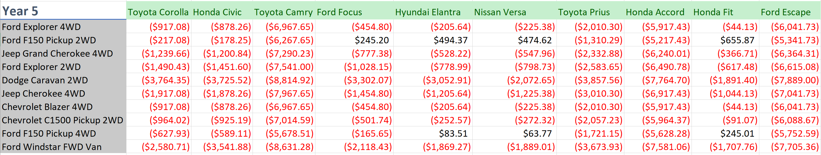

Figure : 5-year plan for customers

The difference of operation costs is low. The credit and if there are any salvage for old cars the difference will become positive. Camry, Accord and Escape costs have a lot of operating cost, but overtime the cost may decrease as they have a better fuel economy as compared to the cars which are traded-in.

For 10 years, almost all the options become a viable option. With the only major difference for Dodge Caravan trade options. Dodge Caravan seems to have a good fuel economy and a relatively low insurance cost.

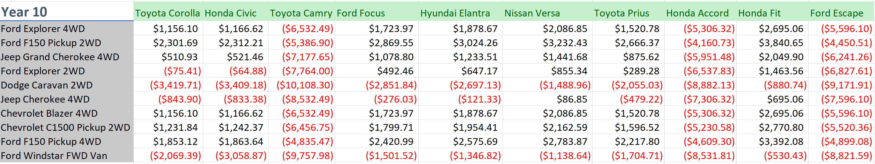

Figure : 10-year plan for consumers

Case 3.

If a consumer wants to trade-in using borrowed funds. All the options turn to red. The interest and principle payment cause the operation costs of new cars to be higher than running the old car. The only car which has a lower operating cost as compared to others. The fuel economy of Toyota Prius might be the main contributor for lowering the operation costs. But still not enough to justify the change in vehicle.

## Corporate Savings

Corporate systems can save a lot by this program. Depreciation plays a major role in net cost savings for new car. For corporate uses, 1-year calculation doesn’t justify because the cost of investment will be too high without a chance of getting any returns.

The 5 year and 10-year plan for costs has all the values in the red. That is mainly due to the cost of investment. The investment cost is too high. But if the investment period is increased by 2 years, there are many suitable options for corporate systems. In case of borrowing funds. The costs of investments start to negate themselves and the savings start to add.

Depreciation is calculated by 5-year MACRS as cited by IRS guidelines for depreciation. For the first 3 years the depreciation is calculated in double declining method and after that by linear depreciation method. Except for Dodge Caravan, all other older cars have a higher operating cost as compared to newer cars.

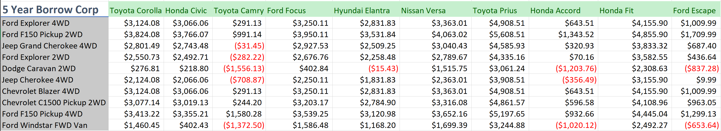

Figure : 5-year corporate borrow plan

If 10-year plan is calculated for corporations the considered, a different outcome appears than the expected one. Some of the cars have a higher operating cost. Therefore, losing some savings as compared with older models.

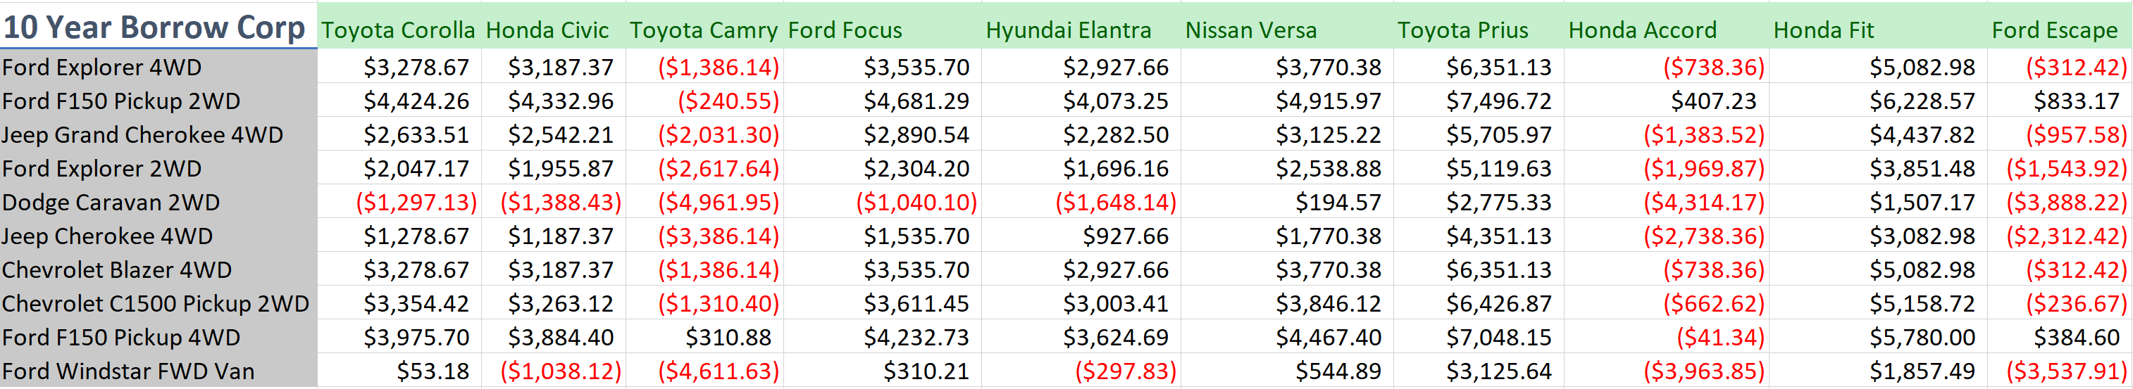

Figure : 10-year corporate borrow plan

Toyota’s Camry, Hondo’s Accord and Ford’s Escape have a higher operating cost. And Dodge Caravan has a better savings as compared to most of models with the exception to Toyota’s Prius.

# Societal Benefits

With a $3 Billion program to convert the less fuel economic cars to a cleaner, greener cars should also carry some social benefits. With about 30 million gallons brought down in the initial year itself the carbon emission would have reduced. Traditional economist would argue that true benefits would be higher as most of the consumers who traded their cars, are likely to be traveling a much larger distance as compared to others. And I concur to that assumption.

In addition to the benefits mentioned above. This program, on an average saved about $125/car and about $0.4 savings on gas.

# Conclusion and Recommendations

Although the author’s views are positive the overall statistics tell a different story. With a savings of $0.4 per gallon, this program should not be used in this form. The cost of the program was quite high as compared to the results it shows. The real program savings of about $0.5 per gallon is also not a quantitatively high number.

If this program was available to consumers having a greater travel distance, this program would have had a better impact than opening the program to all customers. If this program would have been implemented this recent year, the availability of hybrid and electronic cars would have had a greater impact on the whole program [assuming the demand would have been met].

# Assumptions and Model Boundaries

* The interest rate is 5%
* The cost of fuel is assumed to be $2.5
* Average distance travelled is 12000 miles
* The top 10 traded-in cars and the top 10 new cars are 100% account for all the cars.
* Salvage value isn’t part of the old car’s calculations
* Salvage value of new cars after 1 year is 80%, 5 years is 40% and 10 years is 10% of the original price.
* Insurance across the table is yearly insurance cost.
* Purchase Cost of new car is at year 0
* Discount rate is 5%
* Corporations have an annual income of $0
* Fuel economy of all cars in the system are average of the different variants of the cars. Special versions of the car are not kept in consideration.
* Environment costs are not calculated.
* Vehicles are well maintained and have little to no impact on the fuel economy.

# References

|  |  |
| --- | --- |
| [1] | Nick Bunkley, "Government will end clunkers program early," 20 August 2009. [Online]. Available: https://www.nytimes.com/2009/08/21/business/21clunkers.html?_r=1&scp=3&sq=cash%20for%20clunkers&st=cse. [Accessed March 2019]. |
| [2] | I. S. &. Analysis, "Study of the Potential Energy Consumption Impacts of Connected and Automated Vehicles," March 2017. [Online]. Available: https://www.eia.gov/analysis/studies/transportation/automated/pdf/automated_vehicles.pdf. [Accessed March 2019]. |
| [3] | O. R. N. Laboratory, "Transportation Energy Dark Book," U.S. Department of Energy, [Online]. Available: https://www-cta.ornl.gov/data/chapter8.shtml. [Accessed March 2019]. |
| [4] | O. o. E. E. a. R. E. Renew, "www.fueleconomy,gov," U. S. Department of Energy, [Online]. Available: https://www.fueleconomy.gov/. [Accessed March 2019]. |
| [5] | U. S. D. o. Transportation, "Bureau of Transportation Statistics," U. S Department of Transportation , [Online]. Available: https://www.bts.gov/content/number-us-aircraft-vehicles-vessels-and-other-conveyances. [Accessed March 2019]. |